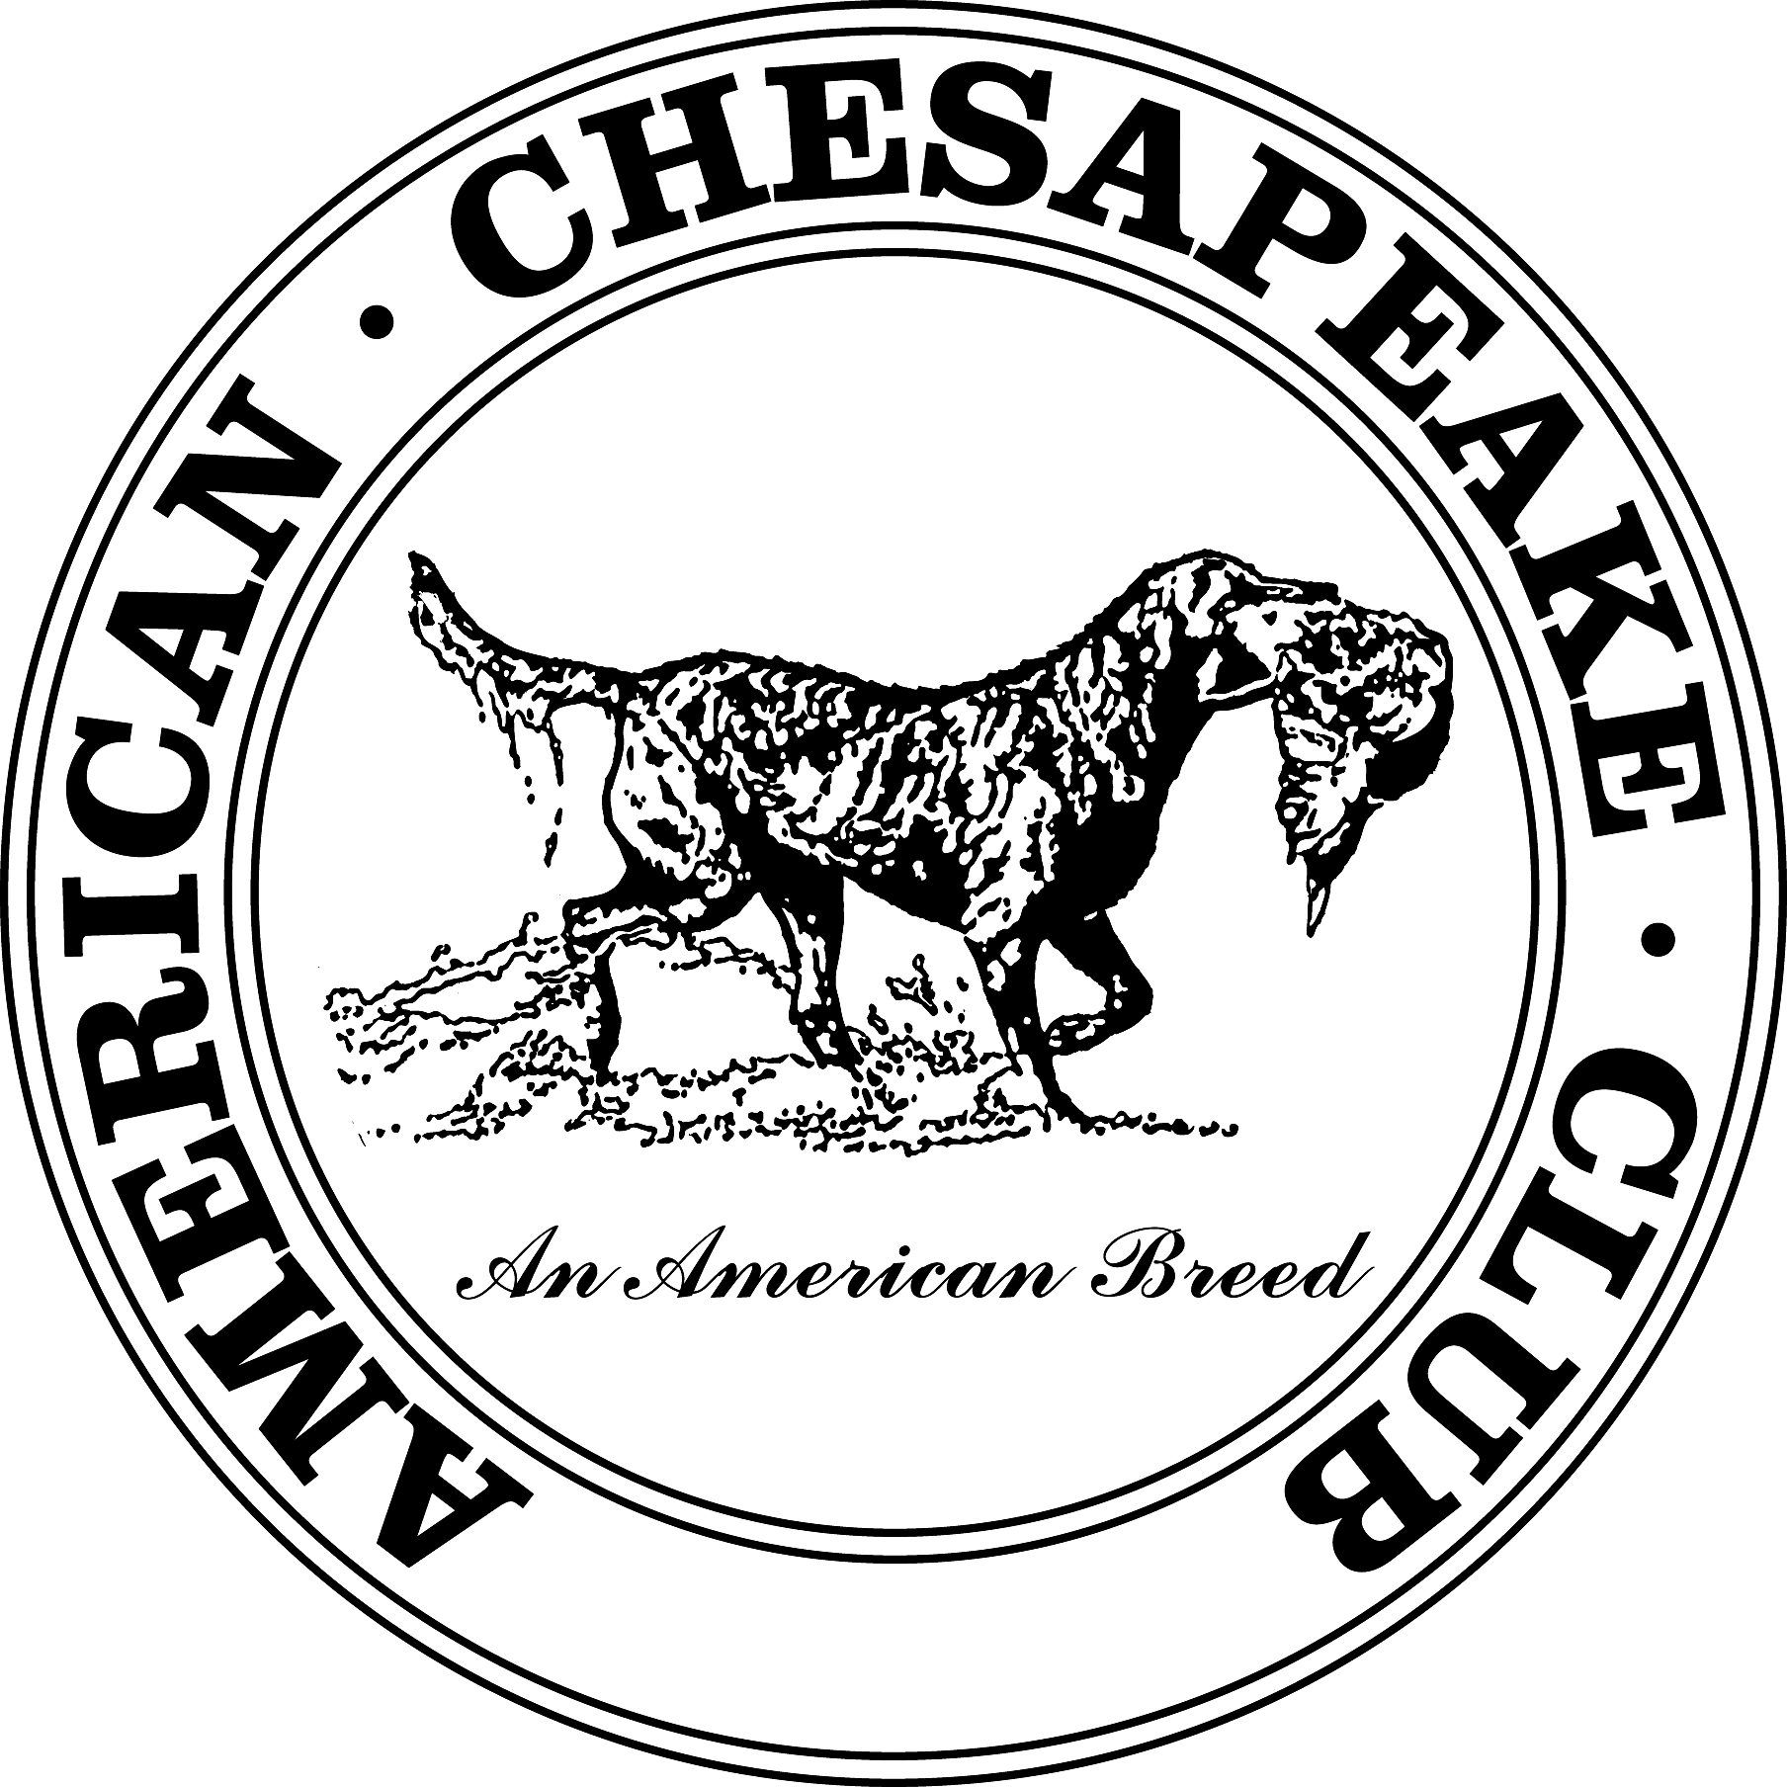 | American Chesapeake Club, Inc.  WD/X/Q Stakes - Oct 11, 2015  Held with the 2015 WI Show Specialty  Open to all Chesapeake Bay Retrievers over 6 months
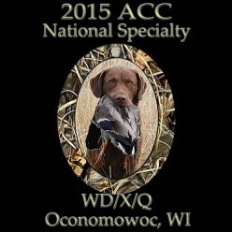

Chairman: JoAnn Stancer, N8767 Larson Rd, Cambria WI 53923 (920) 948-7738 - j_stancer@yahoo.com
Co-Chair: Dana Sunderlage, N6047 Mork Ave, Shawano WI 54166 (715) 853-5356 - dsunderlage@gmail.com
ACC Representative: JoAnn Stancer
Location: The Muth Farm- Eleanor Muth, W1626 Mountain Rd, Theresa, WI 53091 (262) 370-9302 - eleanoremuth@aol.com
Gun Captain and WD Test Supervisor: John Stancer
Judges: Eleanor Muth, Victoria Lunebach, Darrel & Rita Voight
Start Time: 9 am (tentative) Check-in at 8:30am (tentative), WD Test dog at 8:50am and short discussion with the Judges.
**Note-- The WD will run first. Land and water will run simultaneous. There are 4 judges for the WD, each dog will run the Land, if they pass they will take their signed paper and go immediately to the water area. Once the WD is completed two judges will judge the WDX and two will judge the WDQ which will be running simultaneously.
Please have dogs aired and ready to go before it's your turn to be called to the holding blind. All dogs must be kept on lead when not running and must be kept back by the vehicles where they cannot see any of the tests being run.
Fees: ACC Members - $45 for each stake Non-Members - $50 for each stake Pre-Entry Only
Owner must be an ACC member by Entry Deadline to use the member fee.
Entry Deadline: Friday, September 18, 2015 - 6 pm - no phone or email entries – waive signature on overnight couriers.
Entry Form: Use the attached Entry Form (it can be typed on and printed out). Use a separate form for each dog and each stake. Mail entries with check payable to ACC: Dana Sunderlage , N6047 Mork Ave, Shawano WI 54166
**Note – Bitches in season cannot run and are not to be aired on the grounds. Refunds are available. See the instructions in the WD Rules. Please notify us in writing in advance if you need to cancel an entry.
Running Order: a Draw and Running Order will be posted on the website by 10-1-15. Please download your copy of the typed running-order or include your email address and we will email it to you by 10-1-15. Copies will not be available at the WD.
Results and Photos: Results will be posted on the ACC website after the event as soon as possible.
Rules for the WD/X/Q: Copies of all the Rules and Guidelines, procedures and entry form are available for download on the ACC website at http://www.amchessieclub.org on the WD/X/Q pages or on the 2015 WI Show Specialty area. Also download guidelines for Judges & Handlers and Suggested Line Procedures. Read through these rules before the day of the test. The judges will go over the basic rules with everyone quickly before the start of the stake and you can ask a few questions then if needed. Call or email JoAnn or Dana with any questions before the event. Take time to read through the requirements and procedures in advance. This will help you and your dog to be successful and not fail due to handler error. One important rule to remember is you cannot send your dog until you hear the Judge call your number.
Requirements: (see complete info on the printouts listed on the ACC website)
WD: back to back singles on land and water
WDX: a double on land and a double on water, dogs must be steady and deliver to hand
WDQ: a double on land, a land blind, a water blind and a combination triple with two birds in water and one on land. Dogs must be steady and deliver to hand

Directions: Driving time from Olympia Resort is 43 minutes, about 36 miles.
From Olympia Resort: Take Royale Mile Rd to Summit Ave, Head north on Royale Mile Rd toward Grand High Rd (0.1 mi), Take the 3rd right onto Regent Rd (226 ft), Take WI-67 N to County Rd AY in Theresa, Take the 1st left onto Summit Ave (0.4 mi), Slight right onto WI-67 Bypass N (4.2 mi), Take the WI-67 N exit toward Oconomowoc/Mayville/WI-83 N (0.3 mi), Turn right onto WI-67 N (21.5 mi), Turn right onto WI-33 E (2.2 mi), Turn left onto County Rd AY (5.1 mi), Turn right onto WI-28 E/WI-67 N (0.5 mi), Take the 1st left onto County Rd AY (1.2 mi)
GPS: W1626 Mountain Rd, Theresa, WI 53091 Latitude:43.5326499 Longitude: -88.47571299999998
What to Bring: Water for you and your dogs, shade equipment, bug spray, lawn chair, whistle, flat buckle collar and leash, boots, and your lunch. Pickup all trash and take it with you.

Lunch: Participants are responsible for their own lunch. There are several restaurants in Mayville - West of the event on 67/28 (Back Street Cafe, The Pub, Chinese, Mexican & Fast Food) & Lomira - North on 67/28 (Susies Home Cooking, Bublitz's Rest & Ale House, Fast Food - Subway, Mc Donalds, Burger King) as well as gas stations & grocery store, all are about 5 miles from event.
Volunteers needed: Marshals for each stake, person to bag birds for the judges, live-bird gunners, people to pop/throw the dead bird for each stake, equipment luggers, grounds person to oversee parking and post/remove the signs, someone to pickup lunches for the judges, and a test dog for each stake that isn't running. Anyone shooting should have a valid hunting license. Anyone wanting to volunteer for being out in the field bring along white shirt or jacket to wear & ear protection.
Email to volunteer! JoAnn - j_stancer@yahoo.com / Dana - dsunderlage@gmail.com
For all concerned - make sure your dog has had gun fire, bird boys in white coats, and is picking up ducks before the competition. Park vehicles in designated areas only. Smoking can be restricted in game-lands during dry weather. All dogs must be on leash in parking area and when being aired. No dogs permitted near the line except the competing dogs. When dogs are running, please do not walk around in the gallery, avoid loud talking and do not wear white. Any of these can be very distracting to the dogs and the contestants

Hotels: Pet Friendly in Fond Du Lac, WI - Microtel Inn & Suites, 920 S. Military Rd, Fond Du Lac, WI 54937 920-929-4000 Pet fee $10. Super 8, 391 N. Pioneer Rd, Fond Du Lac, WI 54935 920-922-1088 Pet fee $15. Comfort Inn, 77 Holiday Lane, Fond Du Lac, WI 54937 877-424-6423 Pet fee $10. No Pets Allowed - Country Hearth Inn, 645 East Avenue, Lomira, WI 53048 920-269-7477

Veterinarian: Veterinary Village, N11591 Columbia Dr. Lomira, WI 53048 (920) 269-4000 www.veterinaryvillage.com Dr. Marty & Dan Griffiths Hours: Sunday 8 am to 5 pm. 12 miles from The Muth Farm to the clinic.

Entry Form – type in your dog’s info, print, trim around the border and mail entries with check payable to
ACC: Dana Sunderlage, N6047 Mork Ave, Shawano, WI 54166
American Chesapeake Club Entry Form – WD, WDX, WDQ
Event Name: 2015 Wisconsin Show – WD/X/Q Event Date 10/11/2015
Pre-Entry Only Entries Closing: 9/18/15 6pm
E
Stake Entering: ACC Member? Entry Fee:
Full Name of Dog (with Titles)
Sire:

Dam:
Registration # Country of Registry
Date of Birth Sex
Actual Owner(s):

Owner's Address

City: State: Zip:

Email:
Handler’s Name (if different than owner)
Home Phone Cell Phone
Do not write below this line – for Administration only
Judges: Circle One Pass Fail
Judge Signature #1
Judge Signature #2
Judge Signature #3
Judge Signature #4
Event Chairman’s Name & Signature: JoAnn Stancer, Dana Sunderlage
Revised 5-20-15

